MS.NET
Mini Project
Travel Management System
(TMS)

Document Revision History

Date | Revision No. | Author | Summary of Changes
20th Feb. 2014 | 1 | Shashank Saudagar | Initial Draft
11th May 2015 | 1 | Vaishali Kasture | Incorporation as per new curriculum
13th July 2016 | 1 | Vijay Vishwakarma | Incorporating changes as per new curriculum

Table of Contents
Introduction 4
Setup Checklist 4
Instructions 4
Problem Statement 5
Objective 5
Abstract of the project 5
Functional components of the project 6
Technology used: 7
Implementation 8
Summary of the functionality to be built: 8
Guidelines on the functionality to be built: 9

Introduction
This document outlines a mini project for the .NET Line of Technology (LOT). The project is to develop online Travel Expense Management System Application. This document contains the requirements, work flow of the system and gives guidelines on how to build the functionality gradually in each of the course modules of the .NET LOT.

Setup Checklist
Minimum System Requirements
- Intel Pentium 4 and above Windows XP, 2000 and 2003
- Memory 1 GB
- Internet Explorer 6.0 or higher
- SQL Server 2012 client and access to SQL Server 2012 server
- Visual Studio 2013

Instructions
- The code modules in the mini project should follow all the coding standards.
- Create a directory by your name in drive <drive>. In this directory, create a subdirectory MiniProject. Store your Project here.
- You can refer to your course material.
- You may also look up the help provided in the MSDN
- Since this project work will span over couple of months, you will need to take care of maintaining the code

Problem Statement

Objective

Development of Online Travel Management System(TEMS)
Abstract of the project

Travel Management System allows employees to make Travel Requests and process expense claim settlement on a secure website. This will include management of Travel/Movement Request raised by employees and followed by raising travel expenses against travel made and management of expense claim settlement made to the employees.

This system will have two user types: Employee/User and Administrator.

Role of Administrator user:
Administrator user is responsible for managing the employee travel information and enable employee to raise expense claims against the travel made by him/her. Following are the responsibilities of an administrator user.
- Registration of New Employees in the Travel Management system using Registration Form
- View Travel requests made by the employee users
- Edit/Modify Travel Requests made by Employee users
- Approve/ Reject Travel Request
- Approve / Reject Expense claim report raised by Employee users

Role of Employee user:
Employee user is responsible for updating employee details and perform activities like Create Travel Request, View & Search an existing travel request, Raise expense claim for travel made etc. Following are the duties of employee user:
- Update Employee details
- Create Travel Request (should mention: Travel date, apply date, duration & reason for travel)
- Check travel request approval status
- View / Search Travel Request
- Create Expense claim Report
- View / Search Expense Report

Functional components of the project
Application Architecture:
Distributed web applications traditionally to be designed and built across three logical tiers:
- Database Access Layer (DAL)
- Business Logic Layer (BLL)
- Presentation Layer

The DAL refers to the database itself, the stored procedures, and the component that provides an interface to the database. The BLL refers to the component that encapsulates all the business logic of the application. And, the Presentation layer refers to the web application pages.

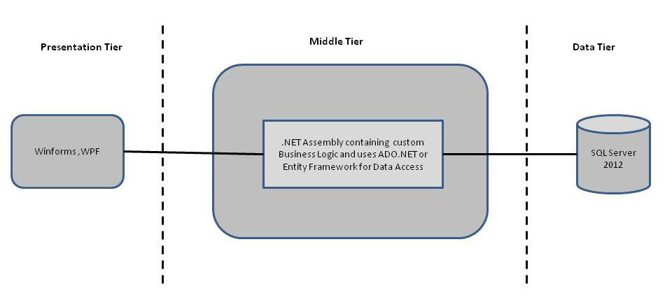

- Design guidelines
- All the exceptions/errors to be captured and user friendly message to be displayed on the CommonError page.
- Data access layer of 3-tier useADO.NET data access using SQL stored procedures - All the database interaction would be performed using Data Access Component. Most common methods in Data Access Component would be –
- Create Connection to the Database
- Create Command Object
- Set Command Type to Stored Procedure
- Create and Populate Parameters
- Execute the Command
- Close the Connection

Technology used:
    - Presentation Layer
      - WPF 4.5

    - Business Layer
      - Business Logic Components and Services :-
        - C# 5.0
    - Database Layer
      - Databases:-
        - SQL Server 2012

Sr. No | Course | Duration | Functionality to be built
Sr. No | Course | (in PDs) | Functionality to be built
1 | MS SQL Server 2012 | 4 | Creating relevant database tables and stored procedures
2 | NET Framework 4.5 + C# 5.0 | 7.5 | Developing Business components (C# classes)
3 | ADO.NET 4.5 | 3 | Integrating the DAL ,BLL and PL
4 | LINQ and Entity Framework | 2 | Creating data model and data context and using LINQ to Entities
5 | WPF 4.5 | 2 | Incorporating advanced UI functionality with WPF 4.5
6 | Mini Project Presentation | 1 | The Mini Project Presentation day

Note: Saturday half day will be devoted for mini project

Implementation

Summary of the functionality to be built:
The participants need to develop the Online Travel Expense Management System by building the functionality incrementally in each of the course modules of .NET LOT.

Guidelines on the functionality to be built:

The functionality and components to be built in each of the course modules of .NET LOT is as follows:
- Course: SQL Server 2012
This section describes some of the basic steps involved in designing and creation of the database for the application.

Create Data Model - identify the different tables and fields that we will need, which would later be used for building the rest of the application.

Database Schema - Taking these objects, we can easily identify our main tables in the database.

  - Create the following database tables with following fields:[make your assumptions incase you require few more fields]
      - Employee Master:Employee_Id,Employee_FirstName,Employee_LastName,Location, Reimbursement_Account_No,Password
      - Travel Details: MR_Number,Employee_Id, Appy_date, Reason_for_Travel,Travel_date,Travel_Mode,FromCity,ToCity,Travel_duration
      - Expense Details :Expense_ReportId,Expense_Type,Expense_Date, Amount_Spent,Payment_Type,MR_Number,Reimbursement_Account_No,Expense_Status
      - Expense_Accepted:Expense_ReportId,Amount_Paid,Payment_Date
      - Expense_Rejected:Expense_ReportId,Reason_for_Rejection,Rejection_Date

- Course: WPF 4.5
  - Develop the prototypes for following functionalities:
    - Login / Sign In: Login screen would display asking user to enter ‘User Id’ & ‘Password’. If the supplied user credentials are valid the HomePage would be displayed, else appropriate Login error message would be displayed
    - First time users Register: First time new users would use this screen to create their profile (userId and password). On click of ‘Submit’ button new user entry (user id & password) would be saved into database table for further user authentication purpose
    - Home Page: On successful user authentication (validation of userid/password provided by the user in login screen) the homepage would be displayed. The Homepage would contain below sections/contents:

Header section: The header section would be common across all the pages and would mainly have –

Sign In Link – On click it would take to Login page

      - Search: Search for Expense Reports based on Employee_Id or Expense_ReportId or Date
Main content section: It would display generic Welcome message giving overview of the site.

  - For Travel :
        - User can create new Travel Request
        - Modify an existing travel Request
        - View/Search an existing Travel Request
        - Delete an existing travel Request
  - For Expense Report :
        - User can Create New Expense Report
        - Modify an existing Expense Report
        - View/Search an existing Expense Report
        - Delete an existing Expense Report

.
  - Employee will have a facility to apply for Travel Cash advance.
  - In this course you need to develop the user interface using Winforms and WPF.The screens should include the fields as per the functionality mentioned above. Include Validations where ever required.

- Course: C# 5.0 and ADO.NET 4.5
  - Develop business components (C# classes) for the above functionality:
    - Employee : This class will be maintaining information about the employee such as employee account number, location, password etc.
    - Travel_Request : This class will maintaining information about travel request
    - Travel_Expense: This class will be maintaining information about travel expenses and claim details
    - Expense_Report: This class will be maintaining information about expense amount paid against a travel expense AND/OR whether the expense claim was accepted or rejected by administrator

You need to create Layered Architecture which comprises of PresentationLayer (winforms,WPF),Business Logic Layer (C# Classes) and DAL Layer(Using ADO.Net 4.5 or Linq and Entity Framework)

DAL Layer of ADO.NET 4.5 will include all the required code snippets for CRUD Operations.

All the CRUD operations should use SQL Server Stored Procedures(For Insert,Update,Delete & Search).

The connectionString should be stored in the configuration file only.

OR

- Course: LINQ and EF
  - Using database first approach create a entity data model based on the database created in the earlier step
    - Employee Class :- This class will hold the information about the employees
    - Travel_Request class:- This class will hold the information about the travel request
    - Travel_Expense class :- This class will hold the information about the Travel expense
    - Expense_Report class :- This class will hold the information about the Expense Report
  - Using the DataContext perform the CRUD operations and using LINQ implement the required business logic (like retrieving data, sorting data, searching data etc).

- Course: ADO.NET 4.5 and WPF 4.5
  - Integrate all screens (Winforms ,WPF ) with business components (C# classes) to complete the entire functionality.

Project Evaluation Guidelines
The project it is to be evaluated based on the following five parameters:

- Proper Database Structure and UI designing as per the specifications –(15 Marks)
  - Proper Database Design and Stored Procedure
  - Visual look and feel of the UI
- Project Completion – (20 Marks)
  - Timely Completion of the project
  - Integration of all component of the system
- Defect free execution – (30 Marks)
  - Error free execution of individual modules and the whole system
  - Validation
  - Functionality as per the specified requirements
- Compliance of standard and guidelines – (15 Marks)
  - Appropriate comments entries
  - Adherence to naming conventions for classes, functions, variables and files
  - Simplicity of user interface and screen layouts
  - Maintainability of codes (for example, no one function should be more than 100 lines)
- Group Presentation and Query handling – (20 Marks)
  - Participants (Group of 3 to 4) to present the project with UML Diagrams(use case diagram and one of the sequence or activity diagram) and PPT

